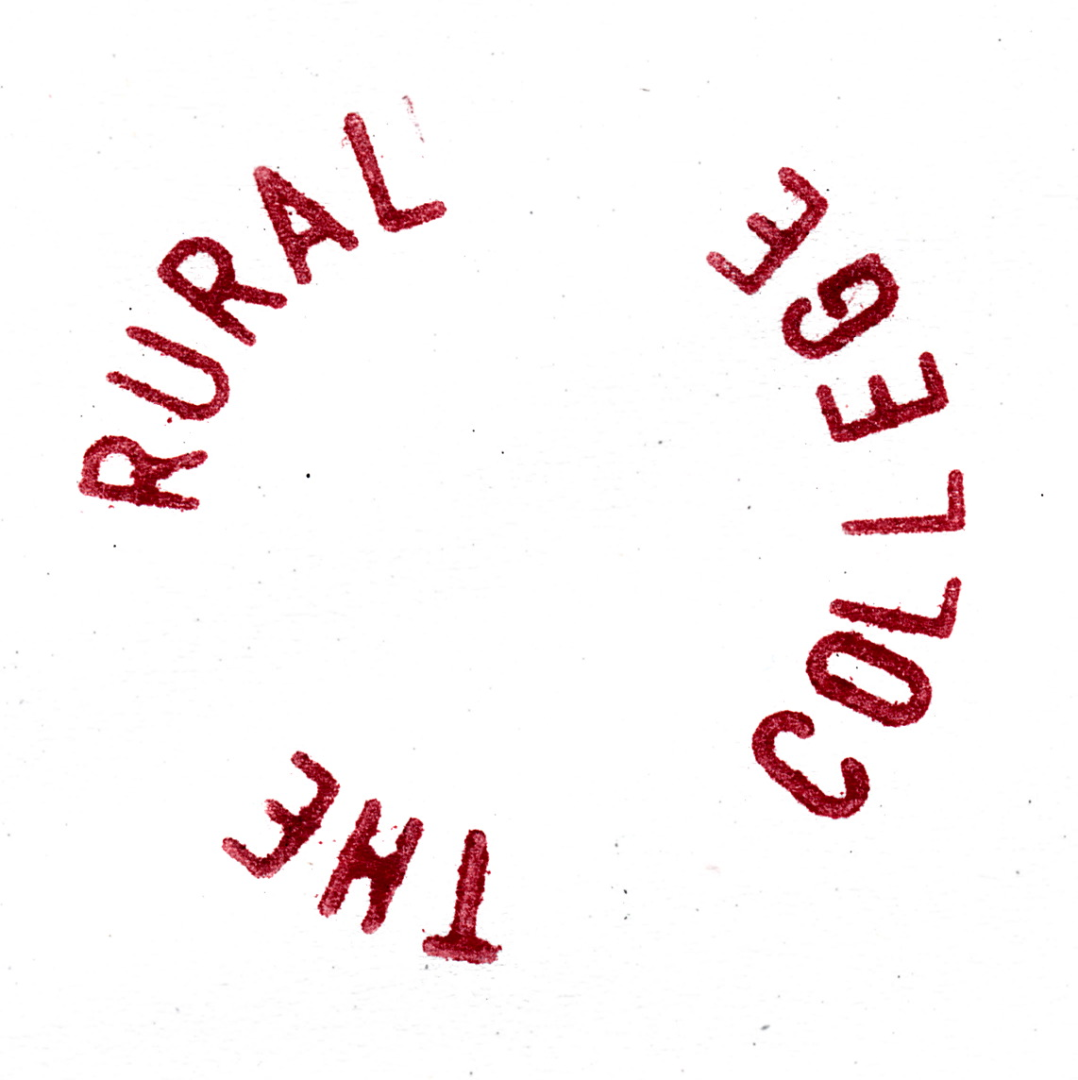

THE RURAL COLLEGE OF ART

12 WINDMILL VILLAS | WINDMILL ROAD

BRADFIELD | ESSEX CO11 2QRE | UK

THE.RURAL.COLLEGE.OF.ART@GMAIL.COM

THE RURAL COLLEGE OF ART IS CURRENTLY INVITING APPLICATIONS FOR:

APPLICATION FORM FOR A M.R.A. TO TAKE PLACE ON SATURDAY 30 MARCH 2013

THIS APPLICATION IS NON-TRANSFERABLE AND FOR A SINGLE NAMED APPLICANT ONLY

KINDLY SUBMIT AS SOON AS POSSIBLE AND BEFORE: FRIDAY 23 MARCH 2013 BY EMAIL OR ROYAL MAIL TO THE COLLEGE.

PLACES ARE FREE THOUGH STRICTLY LIMITED AND MUST BE RESERVED IN ADVANCE.

ALL APPLICANTS WILL BE INFORMED BY 25 MARCH 2013 AT THE LATEST. THE RURAL COLLEGE OF ART TAKES PRIDE IN BEING AN EQUAL OPPORTUNITY PROVIDER

MORE INFO: WWW.DOMOBAAL.COM

WHO

HOW

WHERE

WHAT

WHY